7.16: 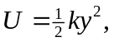 where y is the vertical distance the spring is stretched when the weight 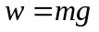 is suspended. 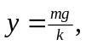 and 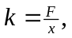 where x and F are the quantities that “calibrate” the spring. Combining,
